**Katsiaryna Rynhel**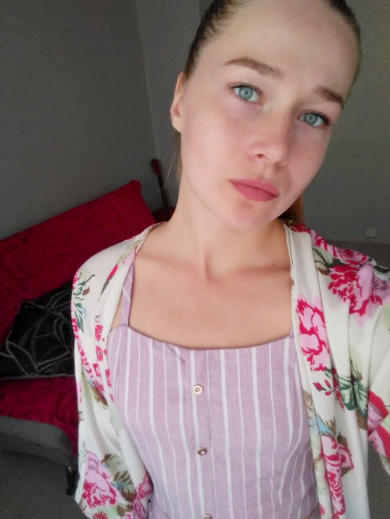

80-809, Gdansk

**Tel. mobile:** +48 791 654 048  
**E-mail:** k.rynhel@gmail.com

**Date of Birth:** July 24, 1997

**Objective:**  
To obtain a position of IT Specialist

**Education:**

2014-2018

BGUFK, Minsk

Tourism manager/physical education teacher

2018-2021

BGEU, Minsk

Manager-economist

**Work Experience:**

2018-2020

School teacher

**Computing Skills:**  
MS PowerPoint, MS Excel, Internet (all popular browsers ), skills of handing multimedia files.

**Language:**  
English – [Intermediate](https://englex.ru/level-intermediate/)

**Personal information:**  
Russian native speaker. Responsible, communicative, work well individually and in team, willing to travel a lot.

**Additional information:**  
Driving license.

**Hobbies:**  
Music, foreign languages, traveling.

**References:**  
available on request.